**TASK DESCRIPTION #2**

* **Use copilot to generate a is_prime python function**

**Prompt-1 : Generate a is_prime python function**

**Prompt-2 :With Examples**

**OUTPUT :**

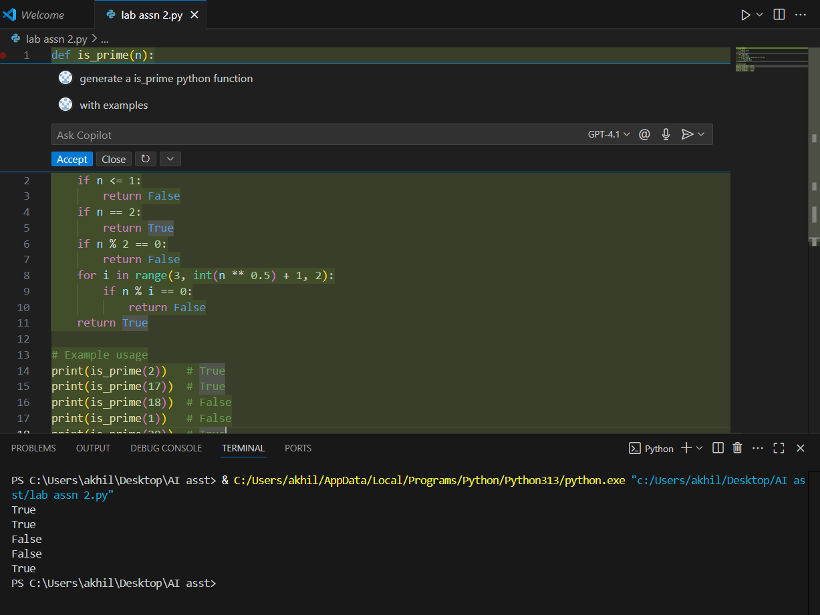

**TASK DESCRIPTION #3**

* **Write a comment like to reverse a string**

**Prompt-1 :Write a comment like function to reverse a string and use copilot to generate the function**

**Prompt-2 : With Examples**

**OUTPUT :**

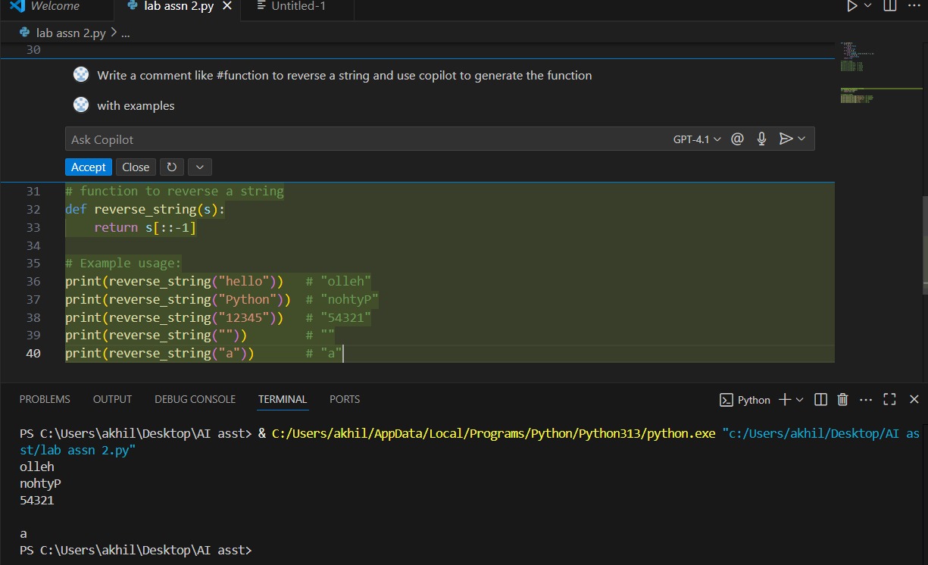

**TASK DESCRIPTION #4**

* **Generate both recursive and iterative versions of a factorial function using comments**

**Prompt : Generate both recursive and iterative versions of a factorial with examples**

**OUTPUT :**

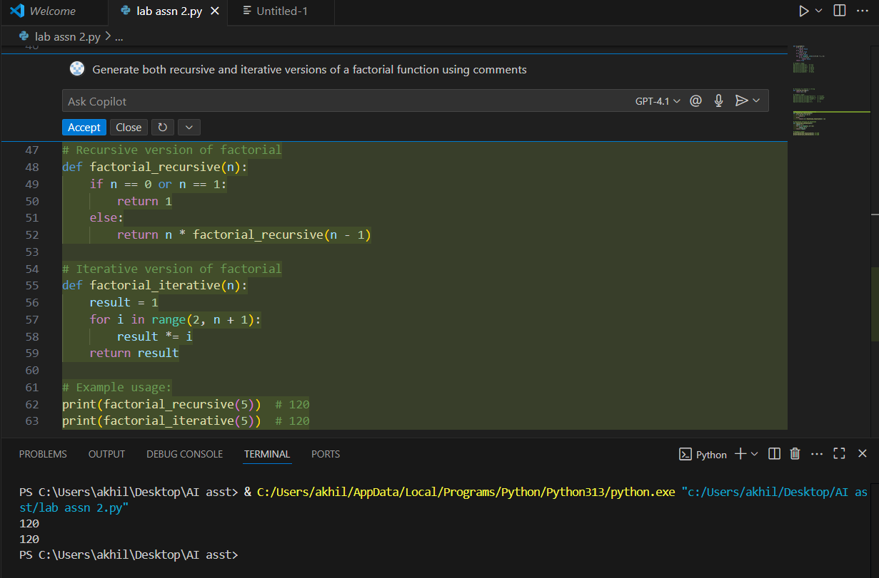

**TASK DESCRIPTION #5**

* **Use copilot to find the largest number in a list Assess code quality and efficiency**

**Prompt : Find the largest number in a list assess code quality and efficiency with examples**

**OUTPUT :**

